Experiment No. 2
Name: Ansari Zeeshan
Roll No.: 14CO16
Sub : HMI
------------------------------------------------------------------------------------------------------------------------------------------
AIM: Know Your Client (KYC)

THEORY:

DIY (Do It Yourself):
Do it yourself (DIY) is the method of building, modifying, or repairing things without the direct aid of experts or professionals. Academic research describes DIY as behaviors where "individuals engage raw and semi-raw materials and component parts to produce, transform, or reconstruct material possessions, including those drawn from the natural environment

The terms "DIY" and "do-it-yourself" are also used to describe:

- Bands or solo artists releasing their music on self-funded record labels.
- Trading of mixtapes as part of cassette culture.
- Designing business cards, invitations and so on.
- Crafts such as knitting, crochet, sewing, handmade jewelry, ceramics.
- Homemade stuffs based on the principles of "Recycle, Reuse & Reduce" (the 3R's). A common term in many Environmental movements encouraging people to reuse old, used objects found in their homes and to recycle simple materials like paper.

Output :

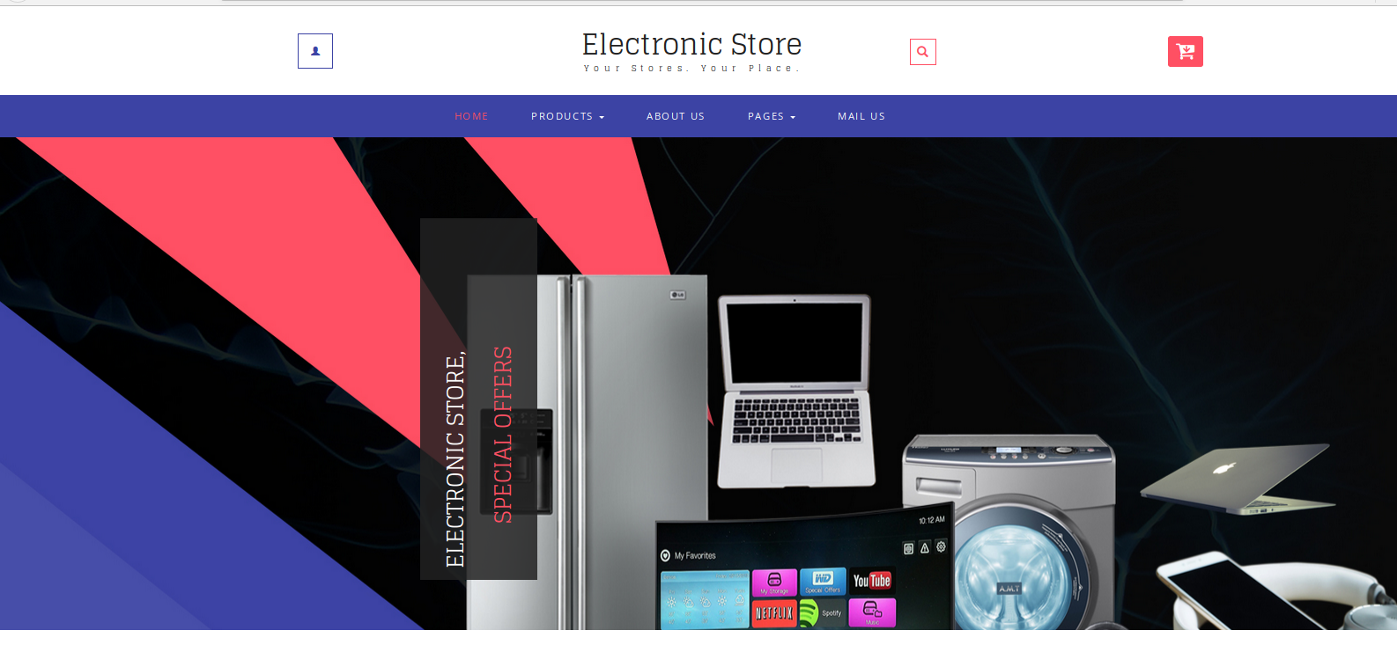








Conclusion:

